PROJECT REPORT

BY

MUBINUN AWAISU

6217000141

ON

DEVELOPMENT OF HEARTBEAT MONITORIN SYSTEM

TIANJIN UNIVERSITY, CHINA

**ABSTRACT**

In this project we presented the design and development of device for measuring heart rate using fingertip to improve estimating the heart rate. As heart related diseases are increasing day by day, the need for an accurate heart rate measuring device or heart monitor is essential to ensure quality of health.

# INTRODUCTION

Nowadays, heartbeat is an important element to be measured. Doctors measure the heartbeat of Human to know the normal heart rate of that person. The reason why, heartbeat measuring device is important is to prevent harmful events from occurring to the human.

This project will focus on two issues, the first issue is regarding the communication between system and user.

Heartbeat Measuring System is a system that can be used in hospitals, and this project will consists of hardware and software. As for hardware part, it will use arduino and the heart sensor and the software is a graphical user interface (GUI).

The heart sensor is 3-pin analog sensor that provides an analog output voltage which is proportional to the measured heartbeat the device has 3 pins: Vs, Gnd, and Vo. Vs and Gnd are connected to the supply voltage and the ground, respectively.

**COMPONENT REQUIRED**

Arduino nano.

Heartbeat sensor.

Connecting wires.

**REQUIRED APP.**

Arduino IDE

Visual studio

**CIRCUIT DIAGRAM**

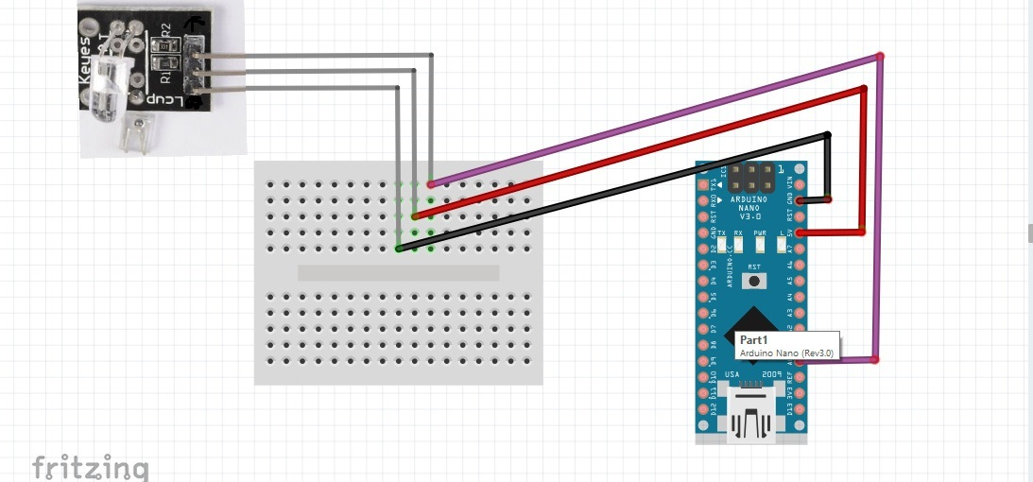

Figure 1: circuit Diagram.

**AIM**

The aim of this project is to design and construct a Pc based heart monitoring System.

The objectives of this project are;

1. Programming Arduino hardware.
2. Design and Development of graphical user interface.

# METHODOLOGY

There are number of methods followed to develop this project before interfacing the hardware and software, from this project, the heart sensor is the input and the output is the heartbeat rate that is displayed on the computer. The heart sensor will sense a finger and then send the signal to the inbuilt analogue to digital converter of the Arduino. The A/D converter converts the analogue signal into digital signal. The Arduino is connected to the computer using communication port and the second part for this project is the software that will display the result.

**RESULT AND DISCUSSION**

Here is the discussion and the principles of operation of the PC based heartbeat measuring device also discusses the software processes and provides brief information on the construction, the circuit is connected as shown above and the code for the arduino to sense the beat of the heart was uploaded, graphical user interface to display the result was developed fig 2, and the information was sent from the arduino to the GUI fig 3.

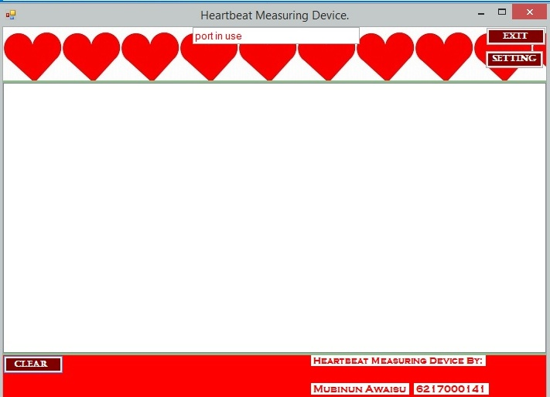

Figure 2: The GUI.

# C:\Users\Mubeenuwais\Pictures\IMG_20171028_012550.jpg

# Figure 3: GUI displaying reading.

# CONCLUSION

This chapter has highlighted the need for heart rate measurement. It has also introduced the concept of this project as well as the method which will be used to realize the device. The aim and objectives of the project have also been outlined and will be implemented.